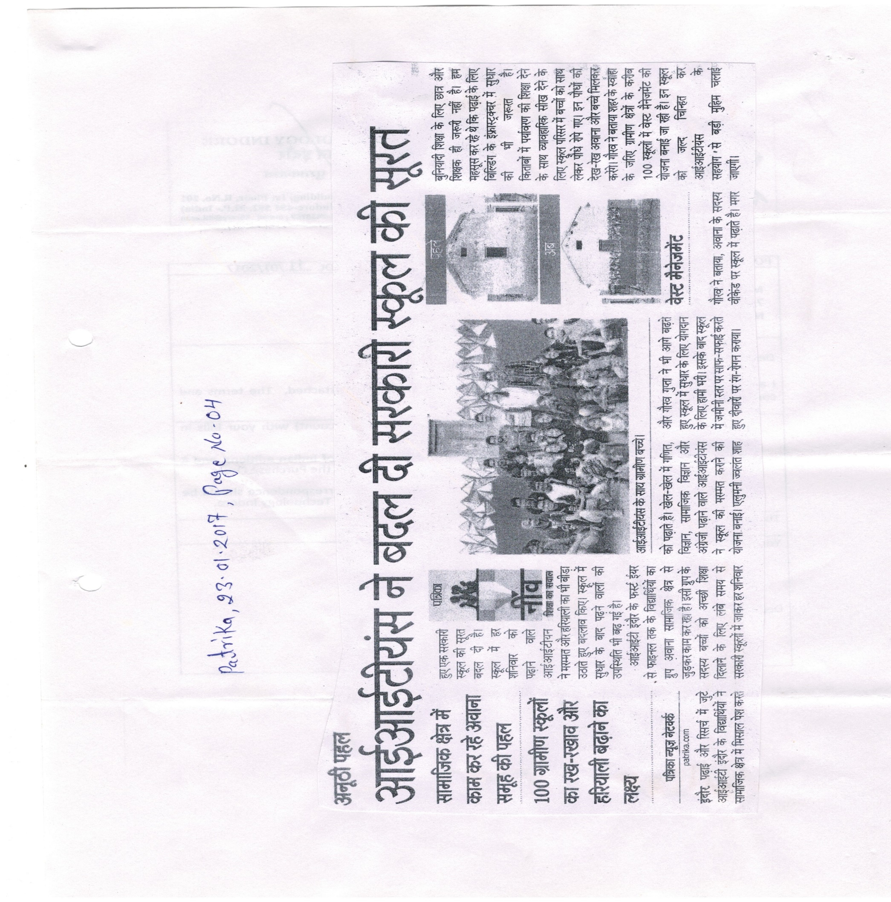**Patrika, 23rd January 2017, Page - 04**