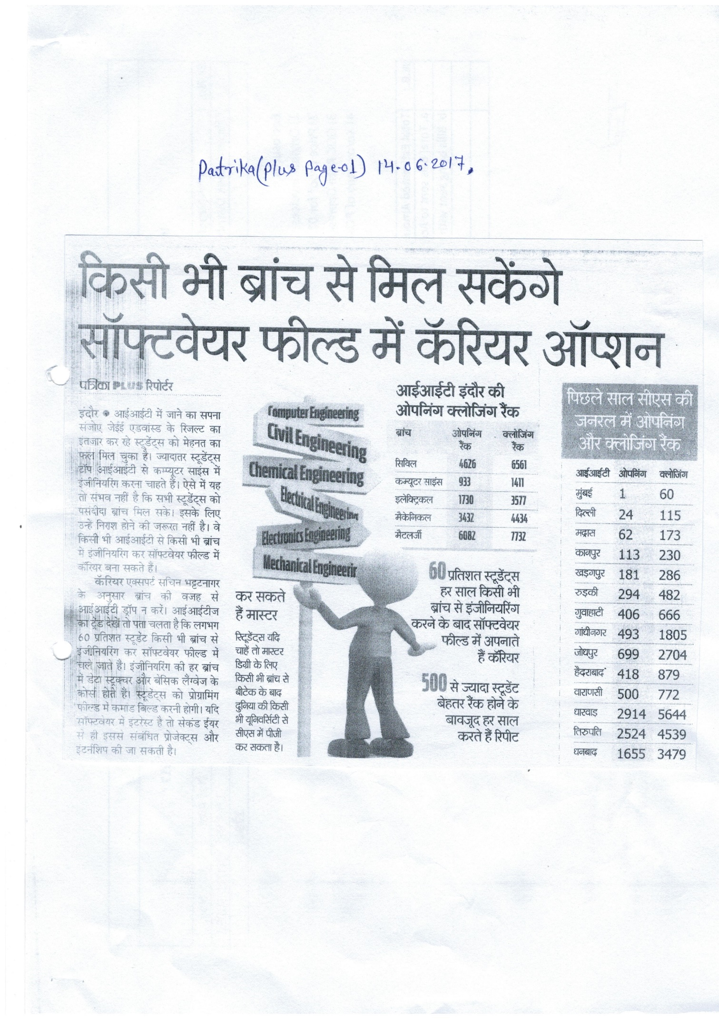**Patrika, 14th June 2017, Patrika Plus, Page – 01**

