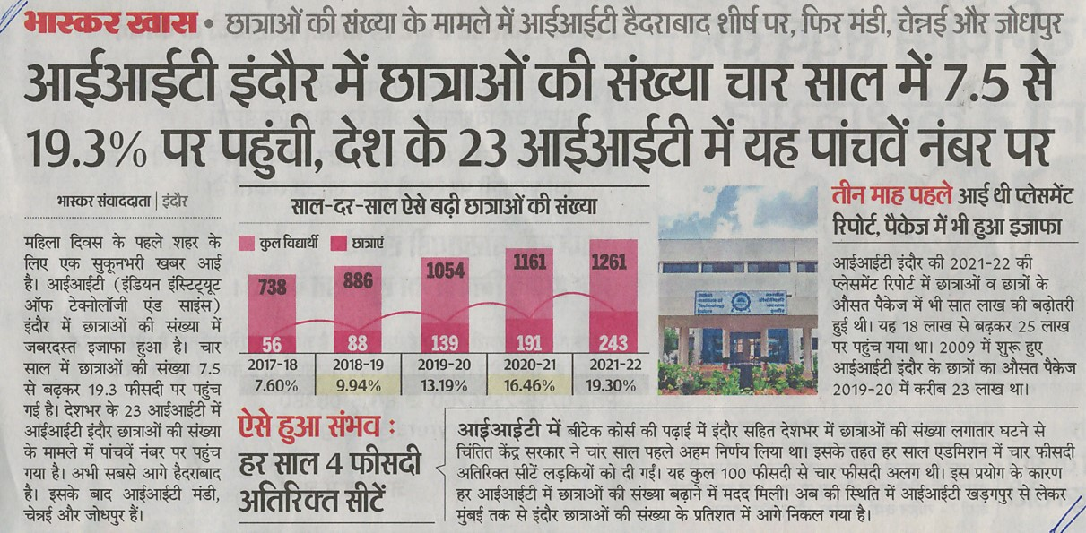**Dainik Bhaskar (Indore), 08th March 2022, Page – 02**